Park Bites Newsletter
Behind the Bites - New Reviews, New Music, New Books, and What's Next
Preview Text
Nearly 40,000 followers, dozens of new food reviews, two new songs, and major progress on several book projects.
PARK BITES WITH AARON
June Creator Update
Hello friends,
Thank you for being part of the Park Bites community. Whether you've been here from the beginning or recently joined us, I appreciate every view, comment, share, and follow.
This newsletter gives you a behind-the-scenes look at the projects I'm working on and what's coming next.
Community Growth
The Park Bites family continues to grow.
• TikTok - Nearly 30,000 followers
• Instagram - Nearly 5,000 followers
• Facebook - Nearly 6,000 followers
• YouTube - Over 400 subscribers
Thank you for helping this community continue to grow.
Food Review Updates
The content machine has been busy.
Over the past few days, I recorded nearly 30 food review videos featuring new menu items, limited-time offerings, and products that caught my attention.
Some of these reviews feature items that scored incredibly high and may be among the best foods I've reviewed this year. Others were disappointed and reminded me that not every new release is a winner.
Restaurant reviews will also be returning soon. At the top of my list are Fairway Donuts and Seven Brothers Restaurant. A new dumpling food trailer recently opened just down the road from my home and will likely be reviewed very soon.
Disneyland Plans
Many people have asked when I'll be returning to Disneyland.
At this point, Oogie Boogie Bash appears to be the next major Disneyland food review trip. There is still a possibility of a July visit, but right now that trip is looking less likely.
If plans change, newsletter subscribers will be among the first to know.
Vegas Possibility
There is a chance I may attend NBA Summer League events in Las Vegas this July.
If that happens, expect plenty of Las Vegas food reviews, restaurant visits, and travel content. Good basketball and good food make a great combination.
Songwriting Update
Two new songs are complete and will be released on Spotify and other streaming platforms soon.
Another City Falls explores the disappointment of job-search rejection and the determination required to keep moving forward.
Learning the Hard Way is a reflection on mistakes, lessons learned, and the realization that sometimes life insists on teaching us things the hard way.
Writing Projects
Flux Venture
Flux Venture is getting very close to publication. I am currently considering releasing it as both a children's picture book and an introductory chapter book.
Anna Untold
I recently completed Chapter 18 of Anna Untold. This first draft is focused on establishing the story and characters, and I honestly believe it has the potential to become one of my strongest books.
An Artist's War: Embers in August
This project is nearing its final revision stage. I still need to add several chapters, strengthen the romance subplot, and add depth to parts of the story.
A Hero's Welcome
This remains my most ambitious project. More than 50 chapters have been written, but there is still considerable work ahead. My goal is for this to become the best story I have ever written.
The Girl with the Frayed Thread
Every time I return to this manuscript, I fall in love with the story all over again. There is still plenty of work to be done, but I remain excited about its future.
A New Steampunk Adventure
Lately, I have felt increasingly drawn to a new steampunk series inspired by the sense of adventure and discovery found in Jules Verne's works. The concept is still developing, but it continues to grow stronger.
Future Merchandise
One project I am seriously considering is creating collectible enamel pins inspired by my books, characters, and personal journey.
Nothing has been finalized, but it is an exciting possibility for the future.
Project Tracker
Want to see everything I'm currently working on?
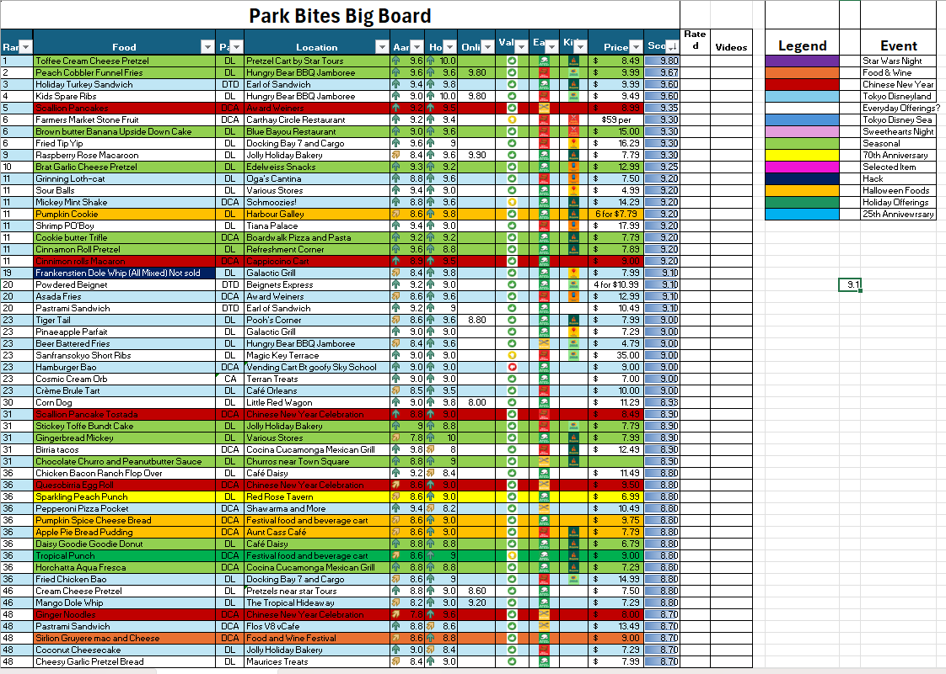
What Would You Like to See Next?
Would you like more Disney food reviews, local restaurant reviews, travel content, songwriting updates, or writing progress reports?
Reply and let me know.
Your feedback helps determine what comes next.
Thank you again for being part of the Park Bites community.
Aaron Vaughn
Park Bites with Aaron

